**Dashboard Design**

|  |  |
| --- | --- |
| Date | 24 September 2024 |
| Team ID | PNT2022TMIDxxxxxx |
| Project Name | Title of Project |
| Maximum Marks | 5 Marks |

Creating an effective dashboard involves thoughtful design to ensure that the presented information is clear, relevant, and easily understandable for the intended audience. Here are some key principles and best practices for dashboard design

**Activity 1: Interactive and visually appealing dashboards**

Creating interactive and visually appealing dashboards involves a combination of thoughtful design, effective use of visual elements, and the incorporation of interactive features. Here are some tips to help you design dashboards that are both visually appealing and engaging for users so take care of below points

* Clear and Intuitive Layout
* Use Appropriate Visualizations
* Colour and Theming
* Interactive Filters and Slicers
* Drill-Down Capabilities
* Responsive Design
* Custom Visuals and Icons
* Use of Infographics

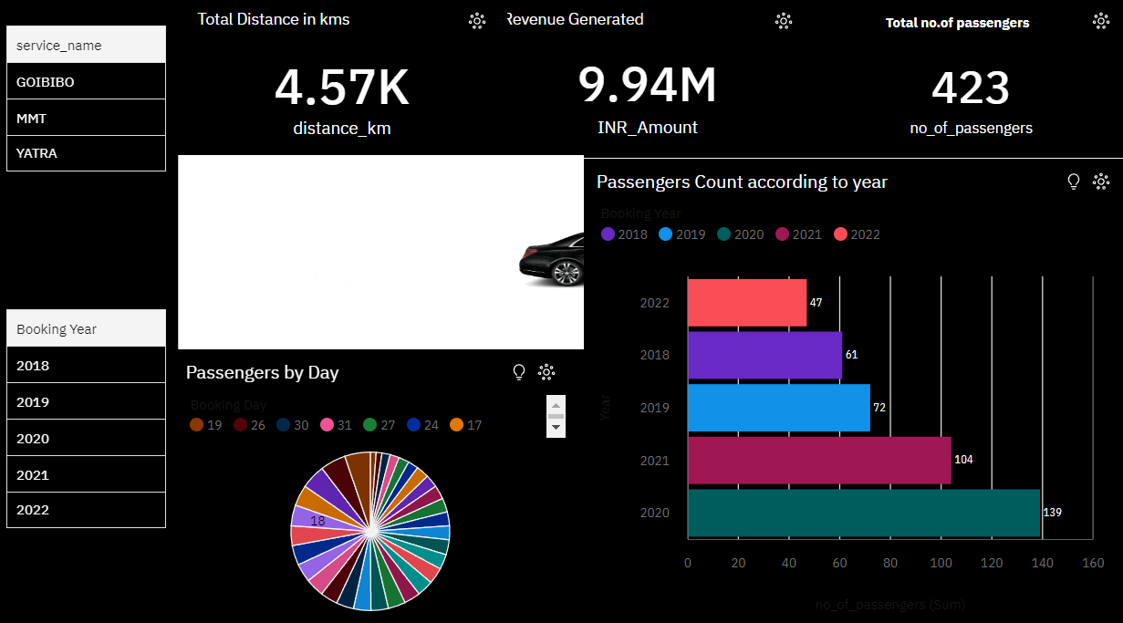

**Note:** Highlight the major outcomes in form of bullet points

Sample:

Here are five potential outcomes from the dashboard image provided:

1. **Total Distance Traveled**: The service has covered a total distance of **4.57K kilometers**, indicating the extent of operations.
2. **Revenue Generation**: The dashboard shows a revenue of **9.94 million INR**, reflecting the financial performance of the service.
3. **Passenger Count**: The total number of passengers recorded is **423**, providing insights into user engagement and service utilization.
4. **Yearly Passenger Trends**: The bar chart indicates the passenger count for each year, highlighting that **2021 had the highest count (104 passengers)**, while **2022 shows a decrease to 47 passengers**.
5. **Daily Passenger Distribution**: The pie chart reveals passenger distribution by day, helping to identify peak days for the service and inform operational adjustments.